And a Nightingale Sang, a wartime comedy by C.P.Taylor
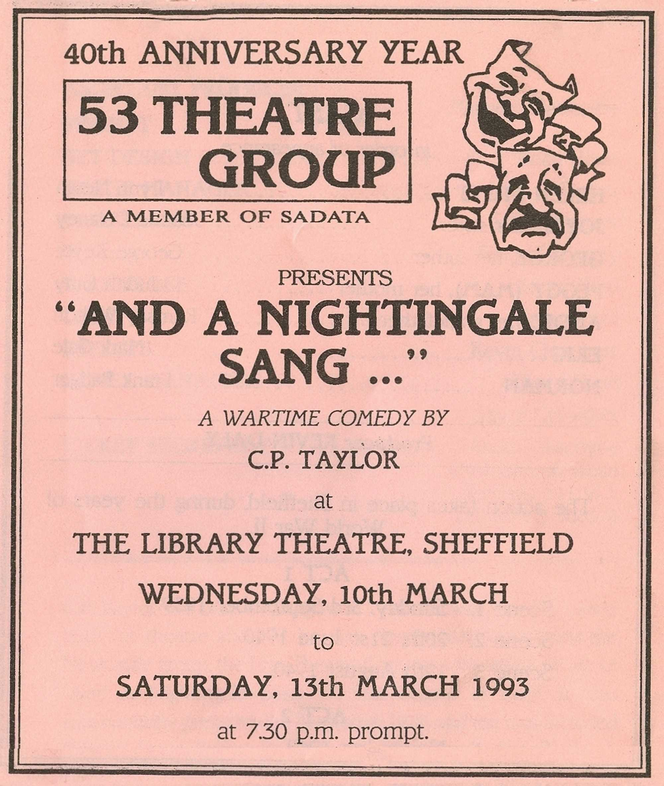
Produced by Kevin Daly
March 1993
Cast
Helen Stott | Lynn Nevin
Joyce | Joanne Delaney
George | George Keyte
Peggy (Mam) | Judith Gray
Andie | Ramsay Walton
Eric | Mark Gale
Norman | Frank Badger


