Birthday Honours, by Paul Jones
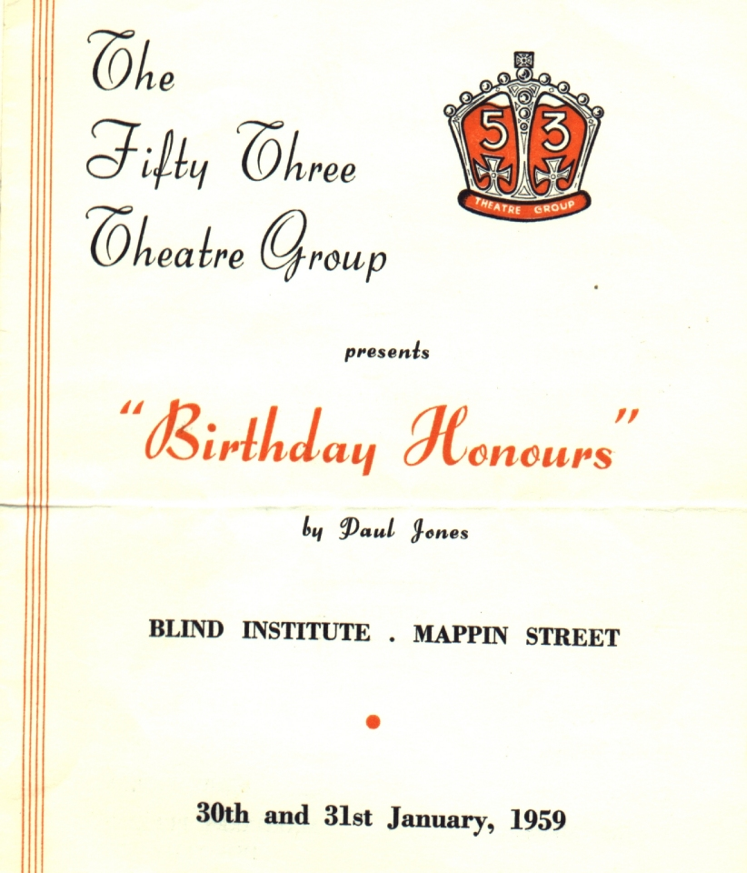
Produced by Royden Beniston
January 1959
Cast
Elizabeth Wilton | Pat Jones
Mary Titheradge | Alice Ludlam
Beatrice Titheradge | Sheila Slack
Alec Bestwood | Arthur Bridges
Monica Bestwood | Barbara Dore
Peter Varley | Neville Dearden


