Shadow in the Sun, by Maurice McLoughlin
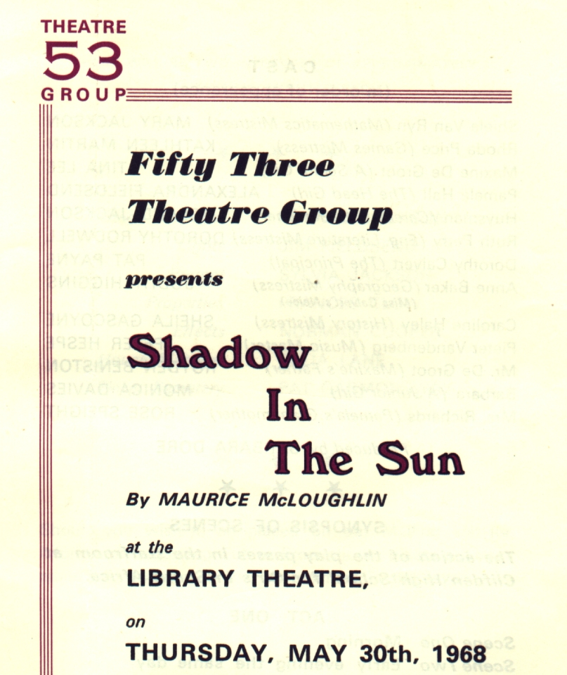
Produced by Barbara Dore
May 1968
Cast
Shiela Van Ryn | Mary Jackson
Rhoda Price | Kathleen Martin
Maxine De Groot | Tina Lee
Pamela Hall | Alexandra Fieldsend
Huysman | Roland Jackson
Ruth Perry | Dorothy Rodwell
Dorothy Calvert | Pat Payne
Anne Baker | Judith Higgins
Caroline Haley | Sheila Gascoyne
Pieter Vandenberg | Peter Hespe
Mr De Groot | Royden Beniston
Barbara | Monica Davies
Mrs Richards | Rose Speight


