The Other Fellow's Oats, by James Pattinson

& Peter Clapham
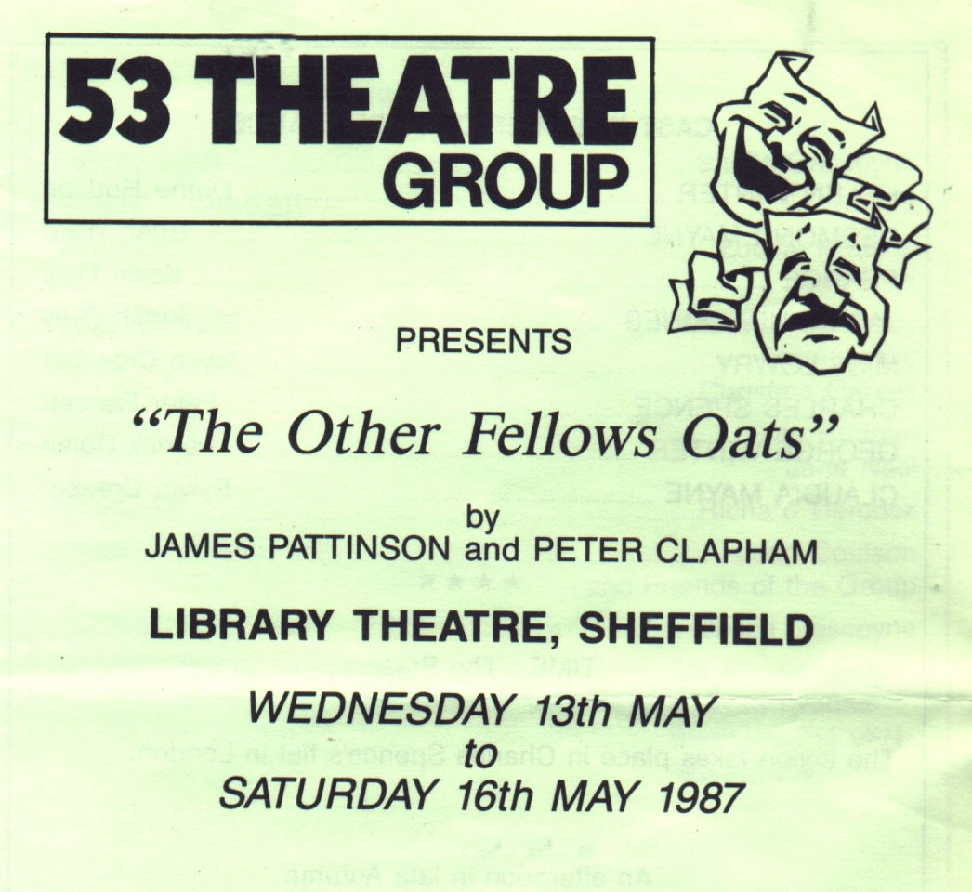
Produced by Sheila Gascoyne
May 1987
Cast
Helen Winter | Lynne Hudson
Desmond Mayne | Brian Ward
Pearce | Kevin Daly
Jacaranda Jones | Judith Gray
Miss Lowry | Joyce Crowther
Charles Spence | Peter Fawcett
George Winter | Patrick Dolan
Claudia Mayne | Sylvia Creaser


