Enter a Free Man, a play by Tom Stoppard
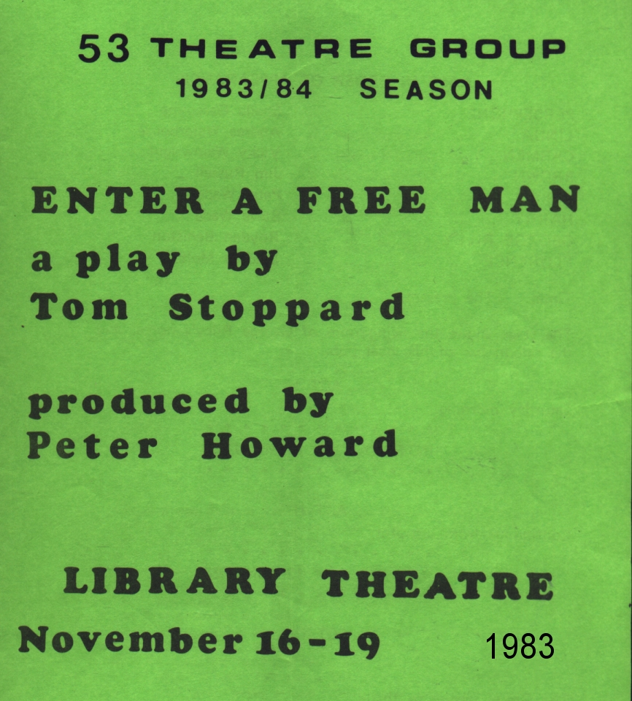
Produced by Peter Howard
November 1983
Cast
Persephone | Sheila Gascoyne
Linda | Andrea Waterhouse
Carmen | Vicky Wainwright
Brown | Jim Russell
Able | Peter Wade
Harry | Steve Wade
George Riley | Royden Beniston
Florence | Lindsay Molton


