The Noble Spaniard, by Somerset Maugham
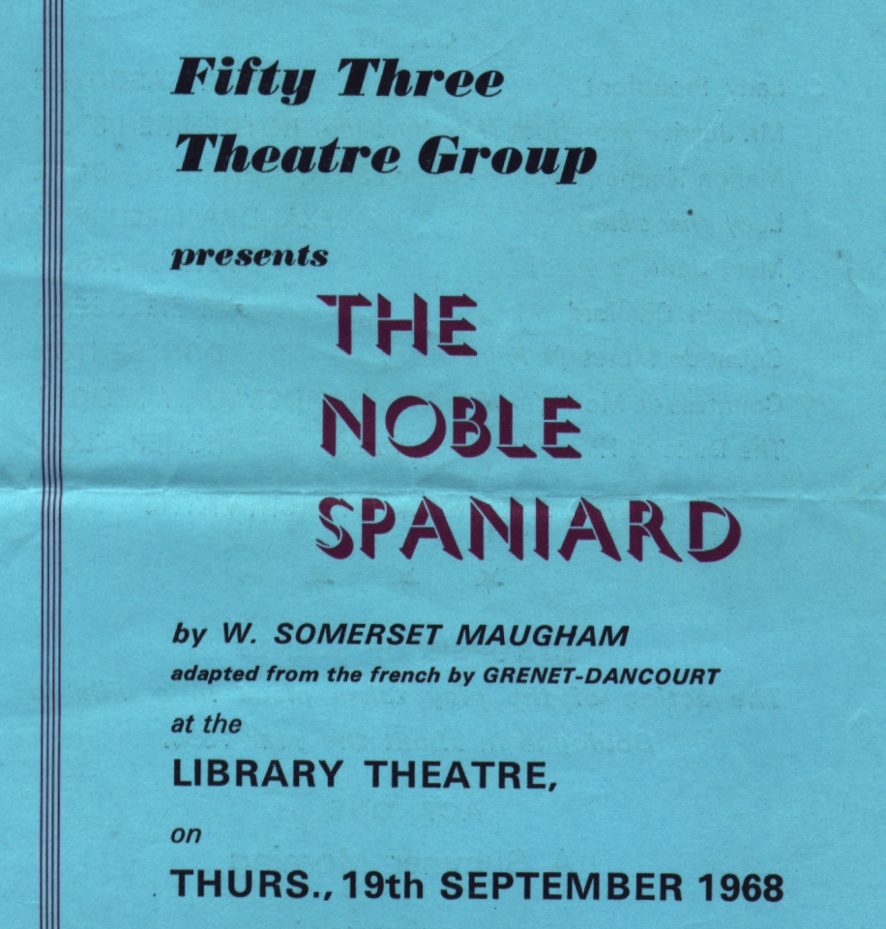
Produced by Patricia Payne
September 1968
Cast
Lady Proudfoot | Sheila Gascoyne
Mr Justice Proudfoot | Royden Beniston
Marion Nairne | Barbara Dore
Lucy | Alexandra Fieldsend
Mary Jane | Mary Jackson
Captain Chalford | Jim Fieldsend
Count de Moret | Don Benton
Countess de Moret | Rosemary Speight
The Duke of Hermanos | Roger Clow


