Murder by the Book, a thriller by Duncan Greenwood

& Robert King
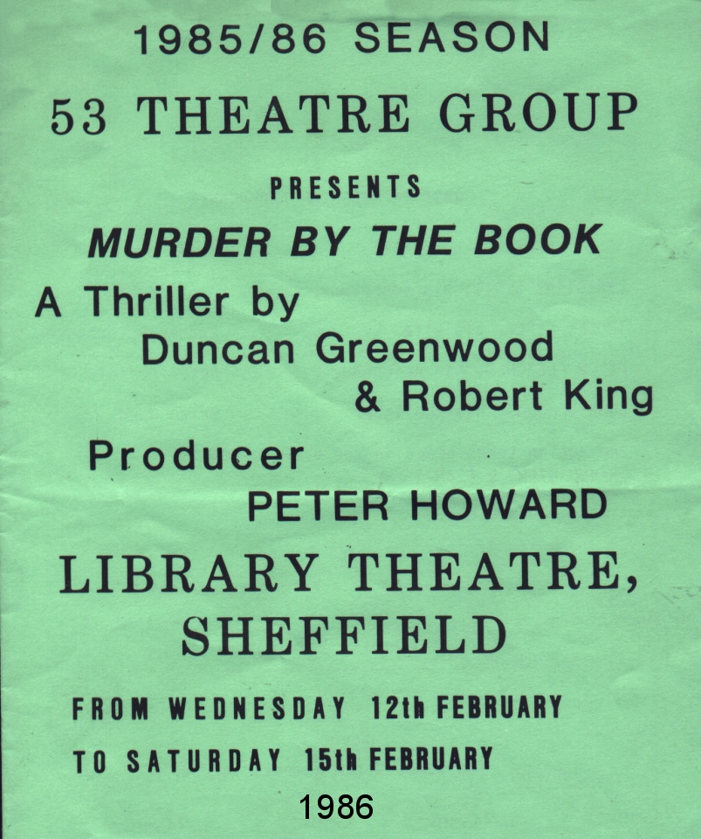
Produced by Peter Howard
February 1986
Cast
Selwyn Piper | Peter Howard
Christine Scott | Anne Ashby
Imogen Piper | Andrea Waterhouse
Peter Fletcher | Peter Arfield
John Douglas | Brian Ward


