All In Good Time, a comedy by Bill Naughton
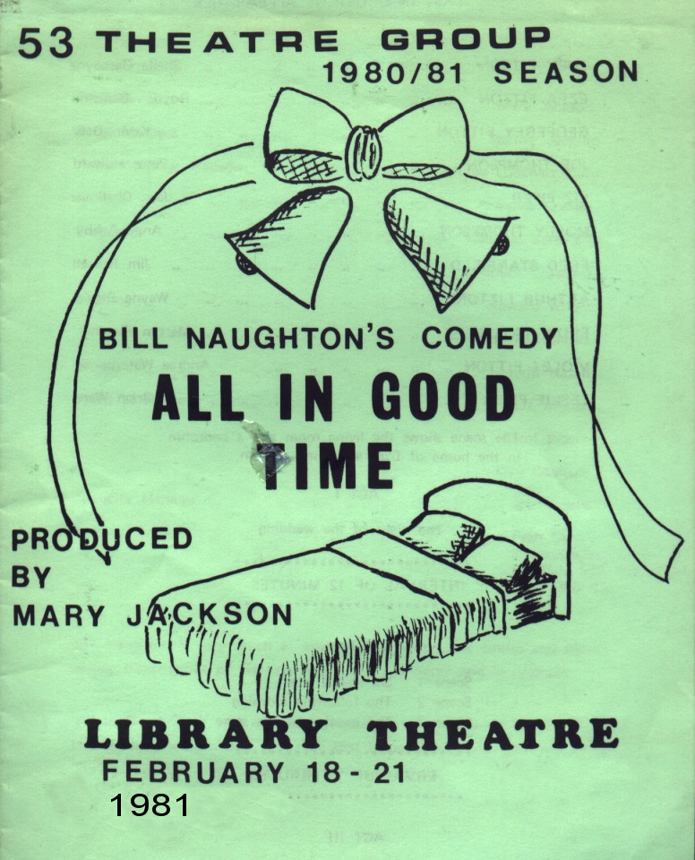
Produced by Mary Jackson
February 1981
Cast
Lucy Fitton | Sheila Gascoyne
Ezra Fitton | Royden Beniston
Geoffrey Fitton | Kevin Daly
Joe Thompson | Peter Howard
Liz Piper | Jean Challoner
Molly Thompson | Anne Ashby
Fred Stanfield | Jim Russell
Arthur Fitton | Wayne Biggin
Eddie Taylor | Martyn Fletcher
Violet Fitton | Andrea Waterhouse
Leslie Piper | Brian Ward


